Healthcare Facilities and Healthcare Professionals: A Targeted Proposal to Reduce Late Cancellation & No-Call-No-Show

By: Benaiah Okara Tel: +4407501175688 Email: Benaiah_okara@yahoo.com

- Executive Summary
A core challenge for the company is balance: specifically, the needs of healthcare professionals (HCPs) and healthcare facilities (HCFs). This year, as we continue to provide services to a two-side marketplace it has come to the fore that when our HCPs actions: late cancellation (or “No-Call-No-Show”) on their shifts, they are creating stress on HCFs and affecting the experience of our facilitators.
In the Cleveland marketplace, only 40% of shifts are completed and verified successfully. Of the 41,040 shifts posted in Cleveland over an eight-month period in 2021, 60% were unfilled and another 13,982 (34.1%) were deleted by facilities, presumably waiting for booking requests. A further 10,658 (25.9%) went completely unfilled meaning for every shift that succeeds roughly 1.5 shifts fail.
Additionally, late cancellations have become a burden on healthcare facilities at a rate of 46.5%. No-Call-No-Show (NCNS) that accounts for 15.3% of all cancellation events across the marketplace gives the facility zero notice, it is only registered after the shift already started. NCNS’s impact on Cleveland market is extensive. For example, in Appendix 1 81.6% of NCNS-affected shifts permanently remain unfilled, compared to 24.2% for non-NCNS shifts overall.
This proposal aims to investigate the drivers behind cancellations: late cancellations (within 24hrs till shift starts) and No-Call-No-Show (NCNS), which is confirmed to be correlated with facility churn. It aims to scope the financial implications, propose a solution and plan to intervene and reduce late cancelations within 180 days.
- Problem Definition
  - The State of the Marketplace
Cleveland marketplace has a 40% success rate. Each shift either gets: Verified – (A worker completed their shift successfully), Deleted (The facility rescinds the vacancy) or Unfilled (It was not verified, it was not deleted)
Outcome | Count | Share
Verified | 16,400 | 40 %
Deleted | 13,982 | 34.1%
Unfilled | 10,658 | 25.9%
It does not portray itself as sustainable. Facilities who use this service may become hesitant in the short-term, seek alternative arrangements and lose trust in the company. This is particularly true if it performs this way for several months
  - Late Cancellations and No-Call-No-Shows
In Appendix 1; there is a remarkable gap between NCNS and non-NCNs related cancellations. An NCNS is heavily detrimental to Cleveland because about 81.6% of shifts cancelled because of a No-Show almost always go permanently unfilled. Cleveland needs to increase its conversion and it can’t keep up with demand if, there is no supply to begin with. For standard cancellations, in contrast the numbers are more favourable at 24.2%, a smaller risk for shifts to go on unfilled. This shows the facilities and professionals i.e. the market is able to recover satisfactorily.
Another reason is NCNS leave zero time to recover, some lead times show negative values that confirm that workers are actively ignoring fulfilling their shift obligations
  - The distribution of Cancellations based on Workers: The Pareto Pattern
The analysis of late cancellation revealed a concentrated distribution pattern consistent with pareto dynamics. This revealed cancellation is driven by a small, identifiable group of HCPs.
From our dataset, 9,933 workers cancelled their shift at least once. The top 20% of employees with cancelled actions are responsible for 61.5% of total cancellations and shown in Appendix 5. Targeted intervention should be focused on this area to achieve a significant impact.
  - Late Cancellation and Agent requirement: CNA Vulnerability
Further analysis on the agents required by a facility identified a significant cancellation risk amongst the Certified Nursing Assistant (CNA) agent category. It is important to note that CNA makes up 60.1% of all shifts and also exhibits the worst reliability metrics of any agent type in the dataset. Shown in Appendix 7, CNAs have the highest vales for cancellation, NCNS, fill rate and caregiver. They represent the largest supply segment in the marketplace.
  - Attendance Policy
In mid-2021, The company launched an attendance policy that did not solve the problem completely. Although it deactivated HCPs that repeatedly cancelled or did not show up. The attendance did move the needle only incrementally according to reports and that was the case as the new data from 2021 showed evidence of chronic late cancellations and NCNSs previously discussed in chapter 2.3.
It is speculated that the attendance policy is levied against an outcome of the true drivers of late cancellations. Hence in Appendix 2, it can be seen that when the cancellation volume is cross-referenced with the ‘Worker ID’ for each of the HCPs that out of these workers, there were 1,505 who had three or more NCNS actions, totalling 64.3% of all NCNS cases within Cleveland, total workers with one NCNS event was 4,774. Despite the threatening policy there is evidence of workers with up to 10 NCNS events. Therefore, there is a lot of delayed action with regards to the policy and workers may be riding their luck and comfortable with the risk they are taking. By this point, in addition to losing revenue – The company also loses supply and this combination drives unfilled shifts upwards compounding its effects.
- Root Cause Analysis
The most common reasons for cancelling are sickness, family emergencies, transport issues and facility-related concerns. These reasons are largely unforeseen circumstances and hard to judge. They are also much harder to reprimand. Where there is a concern is the response to dealing with absences and proactively controlling their frequency
- No Early Detection
there are three strong risk indicators: Worker late cancellation (NCNS) history, Agent type (CNA) and booking lead time. None are being used as a trigger:
Late cancellation history shows 4,774 workers that have at least one NCNS on their record, steps can be taken to intervene and cull that behavioural pattern, to hinder or make repeated offences unpleasant.
Agent type (CNA): CNA shifts are 10x more likely to result in NCNS than RN shifts, these worker types are high risk, as well as being the largest revenue stream for The company.
Booking Lead Time: Shifts booked <12 hours or > 2weeks prior have the highest cancellation rates. See Appendix 4.
- Lack of Multiple Booking Confirmation
There are reminder notifications active, yet within the 48-hour window as shown in appendix 4 cancellations remain high at ~28%. Staff are aware of the upcoming shift, however there is immediate mechanism to follow through to attend
- Consequences are not immediate
The attendance policy punishes after the act, additionally it does so after a series of accumulation of late cancellations. A first-time offender will have room to continue to take advantage of the relaxed rules of engagement and at that point there would be damage done to the facility
- Proposed Solution
Implement a two-layer system:
  - Layer 1: Shift Confirmation Checkpoint system (Proactive)
Upcoming shifts are assigned a risk score based on three risk factors:
- Behaviour history: prior NCNS events, cancellation rate, time since last NCNS (if any)
- Agent Type: CNA (1), LVN (2), RN (3)
- Booking Lead Time: shifts booked >12 hours or > 2 weeks are flagged of higher risk
Table 4.1: Checkpoint Risk Assessment
Risk | Criteria | Confirmation Schedule
High | 2+ NCNS  OR  CNA shift booked > 14 days prior | 120 hrs, 72hrs, 12 hrs
Medium | 1 NCNS OR 1 CNA shift booked 7 – 14 days prior | 24hrs and 12hrs
Low | No NCNS OR Agent required | 36 hrs and 12hrs

Critical Mechanism behind layers
The cut-off point is 12 hours. If no confirmation arrives at that point. The shift is automatically made available for booking, releasing it back in to the market. The benefit of this is that a NCNS will turn in to a late cancellation which his still salvageable. Current recovery rate for standard cancellations 38.3%, more than double that 15.7% recovery rate for NCNS. These are not reminders but requests that require a user input to confirm, cognitively that they will attend that C
  - Layer 2: Tiered Access Restrictions or a Shadow ban (Punishment)
Workers who NCNS despite the confirmation system face immediate, graduated restrictions (Shadow ban):
Table 4.2: Tier Access Restriction
NCNS Count | Restriction | Reversal Condition
1 | Warning issued. Mandatory confirmation checkpoints applied to all future shifts | 5 shifts
2 | Cannot book shifts more than one week in advance | 5 shifts
3 | Deprioritised in shift visibility. Reliable workers see and claim available shifts first | 10 shifts
4 | Single-shift booking only. Must complete current shift before booking another | 10 shifts
5 | Near-full restriction. One available shift per two weeks. Final opportunity before deactivation | 15 shifts

Design Mechanism behind Tiers
This is designed to be strict NCNS. Firstly, to weed out the unreliable staff that will faulter until they either lose interest or deactivate after consistent counts. To see immediate and pronounced changes in NCNS numbers, verified shifts upturn and unfilled shifts decrease.
Every restriction is reversible, no longer a binary system, to protect marketplace supply while still maintaining Immediate consequences. Restrictions are also proportional. First-time offenders get a warning and increased monitoring of shift activity while a fifth time offender is very nearly deactivated.
Unlike previous attendance policies, restrictions are instant and will not tolerate accumulated offences before action is taken. Tier 1 five-consecutive shifts to overturn sanctions the minimum way to prove reliability. Tier 2 seven-day booking limit is perfectly aligned with lead time logic that 2-7 days had the lowest cancellation rates. Tier 3 – ten shifts was done to prevent having a repeat high of over 60% ncns events from that range again.
5. Implementation Plan
Phase 1: Build and Configure (Weeks 1–2)
Objective: Building the infrastructure that powers both layers of the solution.
- Build the risk-scoring model using the historical dataset provided based off the risk data points (NCNS history, Agent type and Booking Lead time
- Map risk level to a confirmation checkpoint schedule
- Build tiered restriction logic for layer 2 into the platform, ready it for activation, include all 5 tiers, escalation triggers and reversal conditions
- Draft and distribute information to all HCPs explaining how these new measure work, triggers, reversals and benefits to reliable workers
- Define tracking metrics and configure dashboards for real-time monitoring if
Phase 2: CNA Pilot (Weeks 3–4)
- Confirmation checkpoints launch on CNA shifts only — 60.1% of volume, 4.2% NCNS rate, maximum signal. Every CNA shift runs through the risk-scored checkpoint schedule. If a worker does not confirm at the 12-hour mark, the shift is automatically reposted.
- Tiered restrictions are not activated yet. The pilot isolates whether checkpoints alone move the NCNS rate.
- Daily tracking: confirmation response rate, non-confirm-to-early-cancel conversion, reposted shift fill rate, CNA and NCNS rate versus baseline.
- Week 3 decision point: if confirmation response rate is below 60%, test SMS-based confirmation alongside in-app.
Phase 3: Full Rollout and Restrictions (Weeks 5–8)
- Week 5: checkpoints expand to LVN and RN shifts. Tiered restrictions activate — any NCNS from Week 3 onwards counts toward a worker's tier. Consequences are visible on the worker's next app session.
- Weekly reporting begins: NCNS rate, late cancel rate, confirmation response rate, reposted shift fill rate, active facility counts, active HCP count by agent type and restriction tier.
- Week 6 decision point: if NCNS rate has not dropped below 2.5%, increase checkpoint frequency for high-risk shifts (add 6-hour checkpoint) and lower - restriction tier thresholds by one NCNS each.
- Week 8: full evaluation against all targets. Each metric compared to pre-pilot baseline with delta expressed in percentage points and estimated revenue impact. Deliverable is a post-pilot report with a clear recommendation: permanent rollout, rollout with modifications, or discontinue.
- If approved for rollout: system transitions to standing operations with monthly model recalibration, quarterly threshold reviews, and ongoing monthly reporting. Ownership of NCNS rate, late cancel rate, and facility retention metrics continues beyond the pilot.
Table 5: Success Metrics
Metric | Current Baseline | Target | By When | Rationale
NCNS rate | 3.1% of Cleveland shifts | 2.0 | Week 8 | 64% of NCNS comes from repeat offenders (1,505 workers). Preventing half of repeat-offender NCNS through tiered restrictions reduces total NCNS by ~32%: 3.1% × 0.68 = 2.1%
Late cancel rate | 8.9% | 6.5 | Week 8 | Confirmation checkpoints convert a portion of late cancellations into early cancellations or confirmed attendances
Confirmation response rate | N/A | 80% | Week 4 | Leading indicator. If workers are not engaging with checkpoints, the prevention layer fails
Reposted shift fill rate | 15.7% (current NCNS) | 35% | Week 6 | Non-confirms at 12h give marketplace 12 hours to find a replacement, approaching the 38.3% general recovery rate
Active facilities posting shifts | ~108 | Maintain or grow | Ongoing | Guardrail metric. Not a target to improve but a floor to protect. Decline indicates facility churn
Active CNA supply | Baseline from week 1 | No More than 10% decline | Ongoing | Guardrail. If tiered restrictions are pushing CNAs off the platform, pause and reassess

5.1. Three failure triggers, each with a defined response:
Trigger 1 — Workers aren't engaging. Confirmation response rate below 60% by Week 3. Response: test SMS and phone-based confirmation in Week 4. If all channels fail, pivot to a pre-shift backup worker system — pre-assigning standby workers to high-risk shifts.
Trigger 2 — NCNS isn't moving. NCNS rate above 2.5% by Week 6. Response: tighten restriction tier thresholds by one NCNS each, increase checkpoint frequency on high-risk shifts. If still above 2.5% at Week 8, conduct root cause review of pilot-period NCNS events to determine whether the risk-scoring model is targeting the wrong shifts.
Trigger 3 — Supply is shrinking. Active CNA count drops more than 10% during any phase. Response: immediately pause tiered restrictions. If the decline is driven by restricted workers leaving the platform, loosen reversal conditions. Supply takes priority — a marketplace with lower NCNS but insufficient workers has not improved.

APPENDIX
APPENDIX 1
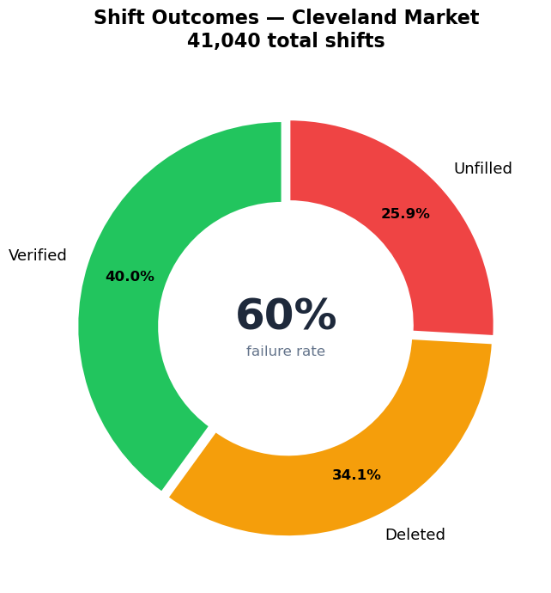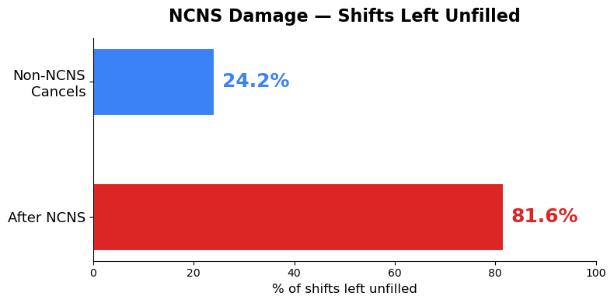
Figure 2(a): Cleveland Shift Outcomes depicting the marketplace (b) NCNS impact overview on
APPENDIX 2
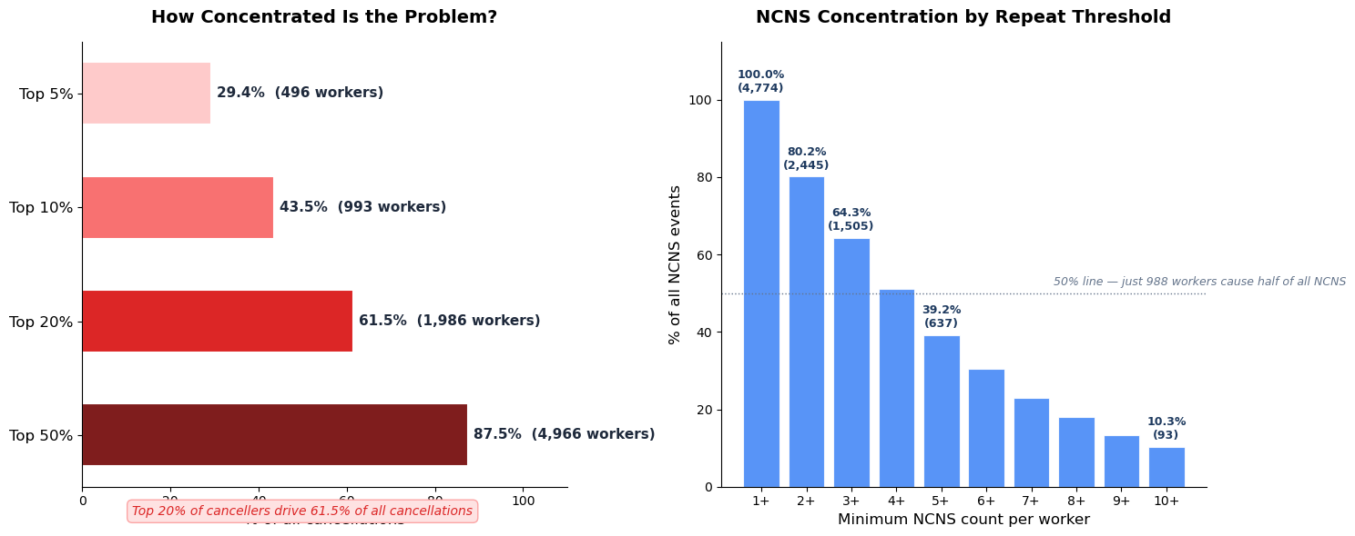
Figure 2(b): Concentration by Repeat Threshold
APPENDIX 3
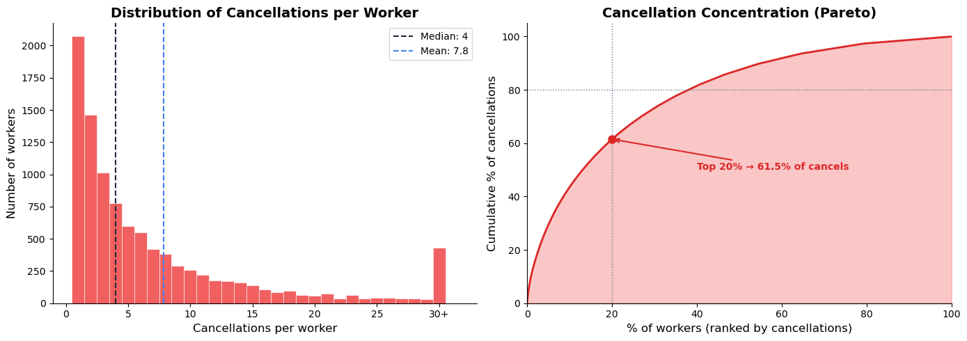
Figure 3: Concentration per worker
APPENDIX 4
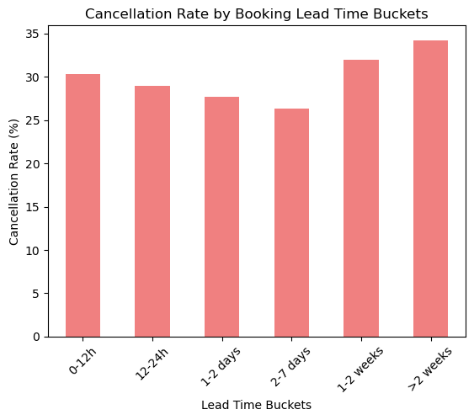
Fig4: Cancellation rate by Booking lead Time
APPENDIX 5

Figure 2(I): Distribution of Cancellation by Worker & Cancellation Concentration

APPENDIX 6
Metric | CNA % | LVN % | RN % | NURSE % | CAREGIVER %
Cancellation rate | 60.1 | 9.57 | 7.07 | 12.48 | 12.90
NCNS rate | 4.2 | 1.3 | 0.4 | 2.62 | 9.68
Fill Rate | 50.7 | 27.6 | 24.91 | 0.16% | 9.68
Average Charge ($) | 30.71 | 47.30 | 63.71 | 0.00 | 30.77
Table 2.4: Cancellation, NCNS and Fill rate of Agent Requirements

APPENDIX 7
Assumptions
- Cleveland dynamics are generalizable across the marketplace (per case instructions)
- Take rate is constant at 22%
- NURSE category (1,907 shifts, $0 charge, 0.2% verification) is excluded from revenue calculations due to apparent data anomaly
- 195 unfilled shifts with booking records but no cancellation records are treated as data anomalies
- Worker deactivation from the 2021 attendance policy may account for some workers appearing in cancel logs but not booking logs
- The top cancellation reasons (sickness, family emergencies, transportation, facility issues) remain consistent across the marketplace
- The confirmation checkpoint system can be built and deployed within 2 weeks — this assumes existing mobile app infrastructure supports in-app confirmation actions
- Booking and cancel logs cover entire market not just Cleveland
- Assumed Nurse category has a data entry anomaly
- Custom shift type is an external arrangement
- Assumed Attendance Policy 2021 was ineffective
- Assumed Worker fatigue was negligent so shift duration did not play a part in analysis

